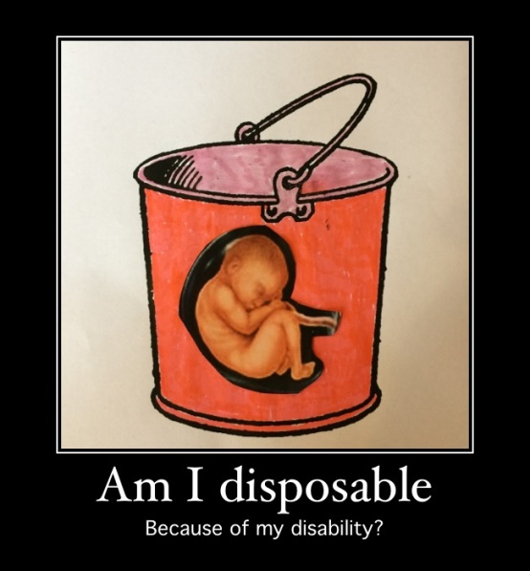

Embryo Screening
Are we becoming a master race? Given that society no longer has room for people who are different, physically and mentally. Hitler has left a legacy that has left its mark on those who are mentally and physically disabled.

And in today’s world things don’t seem to be any different. Medical technology now gives us the choice to make harsh decisions as to whether or not we have an ‘imperfect’ baby. Designer babies appear to be to be all the rage. Would it not be more compassionate to get tools from a DIY shop and create the ‘perfect’ baby of your own? The attitude is inhumane. What kind of society are we becoming? And are there no limitations? How far exactly do we want to go and where is all going to end? This Kind of attitude sends a shiver down my spine. Are we reaching a point where these ‘perfect’ human beings have to be mass produced, be created in factories and boxed up? It is possible for fiction to become reality? These horrendous things are only supposed to take place in horror movies.

By Katie Lord (2006)

