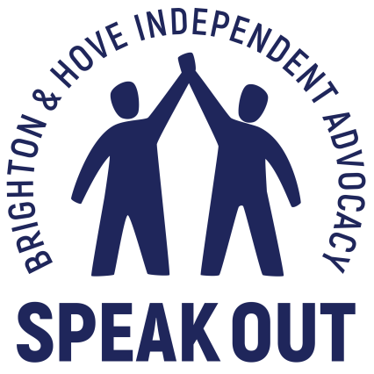

Mental Health Support for People with Learning Disabilities

Brighton and Hove

A consultation with people with learning disabilities

Brighton and Hove Speak Out

Jan 2020 – April 2020

Speak Out
Speak Out is an independent advocacy organisation working with adults with learning disabilities living in the Brighton and Hove area. We work with people in several ways including 1:1 issue advocacy, Self-advocacy groups and drop in services around the city. Our self-advocacy groups represent key demographics, such as young people, older people and an LGBTQ group. We also have a regular presence in day services, sheltered housing, residential homes and supported living throughout Brighton and Hove. We continue to explore new ways of engaging hard to reach and marginalised individuals whose views often go unexpressed.

Consultation subject: Mental Health Support
From April 2019 Speak Out has been carrying out open consultation work with adults with learning disabilities in Brighton and Hove. The purpose of this work has been to identify the key issues that people with learning disabilities say affect their health, well-being and quality of life. This work is informing the council’s Learning Disability Strategy 2020 – 2024. It is also supporting projects such as Thumbs Up To Good Health which aims to address the significant health inequalities that people with learning disabilities face locally and nationally.
Mental health is the subject that people with learning disabilities are most keen to address.
The majority of respondents cite mental health support as the biggest barrier they face to improving the quality of their lives, health and wellbeing. Isolation and loneliness were a close second with many people saying they feel marginalised and misunderstood. Others state that without support they are unable to initiate or sustain friendships and relationships.
This Report
This report will examine:
- The prevalence of depression and anxiety among people with learning disabilities
- What opportunities people get to express how they feel
- What happens when someone says they need support
- Where do people find support when they need it
- The levels of isolation that people experience

Methodology:
During the consultation period January 2020 until march 2020 Speak Out consulted 27 people with learning disabilities around the city.
- Individual private interviews
- 1 older persons focus group
- 1 younger persons focus group
- Drop in attendees
- 3 ‘pop up’ drop ins: Team Domenica, Patching Lodge, St John’s
- Day service users at Grace Eyre
All interviews were face to face in locations chosen by interviewees. Discussion consisted of set questions to prompt exploration of personal experiences and views.
In addition we were able to draw on a body of work based on the views of people with learning disabilities around issues such as: wellbeing, Health Improvement services, access to activities and information.
Demographic:
All participants were residents of Brighton and Hove and between the ages of 16 and 85.

Overview
People with learning disabilities are able to identify that they are experiencing mental health difficulties. When they express concerns to GPs and other health and social care staff they are not taken seriously. Many speak of feeling ‘fobbed off’ or ‘passed around’.
People reported that their lifestyle deteriorates when they are in a mental health crisis: leading to a worsening of pre-existing medical conditions. Other negative impacts include disengagement from health and social care services resulting in unsafe situations and behaviours.
In addition it is clear that people with learning disabilities face significant barriers to adopting the lifestyle habits associated with wellbeing.

People with Learning Disabilities and Mental Health
For people with learning disabilities the same issues can lead to depression that affect all of us. Things like a lack of social networks, loss such as bereavement or change of support staff, realising they have fewer opportunities such as being able to work or have a family
Whilst around 6% of the mainstream population experiences depression in any one year (NHS), studies suggest that up to 20% of people with learning disabilities will experience depression.
Factors such as fewer psychological and material resources to deal with adversity and lack of meaningful activities in their lives can increase the chances of people with learning disabilities developing depression.
The most common long term health condition in Brighton and Hove is anxiety.
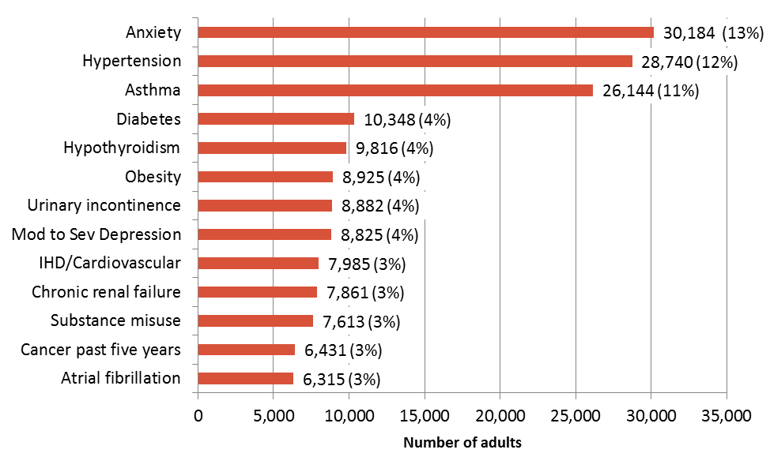

Isolation
Brighton and Hove has been identified as having one of the highest rates of loneliness in the country. This not only affects people’s mental health and wellbeing, but also leaves them more vulnerable to abuse and unhealthy relationships. ‘Loneliness is associated with physical and mental health problems and poorer quality of life.’ (Gilmore & Cuskelly, 2014).
The effects of loneliness and isolation on health and wellbeing are well documented:
- Loneliness, living alone and poor social connections are as bad for your health as smoking 15 cigarettes a day.
- Loneliness has a more negative effect on health than obesity and is likely to increase risk of death by 29%
- Lonely people are more likely to suffer from dementia, heart disease and depression.
People with learning disabilities tell us that they experience levels of loneliness and isolation that have a negative impact on their health and wellbeing. In a recent survey of people with a learning disability, Mencap found that “24% said they felt lonely ‘a lot’. This compares to just 3.4% of the general population who said they felt lonely ‘often or always.”
There have been advances in the rights of people with learning disabilities in recent years. They are experiencing more choices and opportunities than they have done historically. However, young people with learning disabilities are facing a loneliness epidemic.
Research suggests that 1 in 3 young people with a learning disability spend less than 1 hour outside their home on a typical Saturday (Mencap, 2019).
In a survey by Sense, over half of disabled people reported feeling lonely, rising to over three quarters (77%) for those aged 18-34 (Sense 2017).

How is your mental health?

Over the last few years it has become more commonplace to discuss mental health issues. People feel more able to share their experiences of depression and anxiety. People with learning disabilities are much better able to recognise and express concerns if they have an opportunity to explore their mental state.
Speak Out staff have noted that people with learning disabilities who attend drop ins and self-advocacy groups are keen to talk about mental health with their peers. Many say this is the only opportunity they have to speak openly with others who understand them.

However there are people with higher support needs who are experiencing distress they are unable to identify or express. The same is true of older people who have been in institutions the past. Many have lived in settings where their mental health and wellbeing went unacknowledged and ignored. These people minimise negative experiences, never having had the opportunity to explore their feelings.

‘We are the same as everyone else. We get sad about the same things. The same things happen to us.’

People with learning disabilities are able to understand and identify mental ill health. Over 60% of respondents said they experience anxiety and depression that has a significant effect on their wellbeing and lifestyle. Despite being eager to discuss these issues they say that the support they need is out of reach and their voices often go unheard.

Who do you talk to?

People with learning disabilities are speaking up more than ever about the mental health crisis they are facing. Interviews reveal that people find it hard to know who to go to for help and support.

Living at home.
K is 27 and lives with her parents.
She suffers from anxiety and feels lonely and isolated. Her mother works full time and K receives no social care support. She believes that some support would help her but has been refused. The result is that her physical health is suffering.
She told us that they feel like a burden on their family because they have been unable to access adequate mental health support

‘They say you need to speak up about mental health, but if you do you just get ignored. My mum had to come to the doctor's with me, I don’t get any other support. They gave me pills which help a bit. I feel bad because the only person I can go to is my mum. She has enough to do. I just don’t want to go out or do anything.’

Supported living
N is 40 years old. He is non-verbal, he communicates with movement and receives 24 hour support. He has a variety of interests and is a member of many groups and organisations, both mainstream and specialist.

He says he excellent support staff who do their utmost to ensure his voice is heard and respect his views and needs. However he was disappointed by his GPs reaction to his request for support.

‘Support staff noticed I was very low. There were things that were really upsetting me. We went to the doctor because I needed help. But they said ‘Just have a chat with staff at home if you feel low’. That is not what I needed. I needed counselling but they sent me away.’

Shared lives

M is 38 years old. She lives in a shared lives placement and has a high level of independence. She travels independently and volunteers in 2 groups.

She experiences overwhelming periods of anxiety and has just received a diagnosis of autism. Her shared lives carer acts as her advocate and worked hard to secure an assessment for autism and a course of CBT to address anxiety and phobias.

‘With me I worry about silly things and they get really big in my head. I feel like no one understands. You feel like it doesn’t matter about people with learning disabilities. We get upset the same as everyone else. But no one listens. My carer comes with me to the doctor, she takes care of it. The CBT helped. The woman really helped. But it’s finished now. I needed longer.’

Independent Living
B, 54 years old.
B lives independently, receives 3 hours support a week and suffers from epilepsy. She has an anxiety disorder that results in obsessive thoughts and worries.

‘For me it all starts with mental health. I know I am less well when I am anxious. People do not want to hear it. They say ‘You should stop thinking about it. You shouldn’t talk about it.’ So they try and keep information from me so I don’t worry. I like to know about the conditions I have. It’s hard to get information because they say I don’t need to know.
I would like support with my mental health. I don’t get anything. Support workers do not want to know. When I get desperate I ring the Samaritans. I do that more often than I would like to. I know that I have more serious fits when I am anxious. It is very frightening.’

What happens when nobody listens?

Everyone questioned said that they had not been offered adequate mental health support. Many said they had felt fobbed off, ignored or patronised. Most said that their levels of distress were underrated and minimised due to their learning disability.
We asked people what happens when their mental health concerns are side-lined.

What people told us

Inappropriate use of emergency care services
‘I was in a bad way. I went to A and E again. I wanted help.’
Self-harm
‘It’s like you have to hit rock bottom before anyone will do anything.’
Disengagement from social services
Isolation
‘It gets so I can’t go out or see anyone.’

What we have observed
Alcohol misuse
Destructive behaviour and relationships
Poor physical health
Self-neglect
Aggression leading to police involvement
Vulnerability to exploitation

Prevention and ‘Self-Care’

The NHS long term plan emphasises the role of prevention in tackling the most common health complaints. Central to the idea of prevention are lifestyle changes and self-management of conditions. Many people manage mental health problems with changes to their routine, diet, exercise and interests. GPs, NHS information and mental health organisations promote the effectiveness of these changes and research bears out their usefulness.
However self-management and prevention become more complex when support needs, access issues and health inequalities are part of the picture. We asked people how they would be able to put MIND’s Self-Care recommendations into practice.

- Talk to someone you trust
People said it’s hard to find someone to talk to.
Some say it’s hard to talk to family members because they might have mental health problems themselves. Others say they feel like a burden.
Support workers don’t have time to listen. They do not know where to signpost people for support.
People tell us that GPs do not offer support or referrals.
People say there is still a stigma around mental health despite a more open public debate.
3 respondents said that the general population don’t understand that people with learning disabilities can have mental health problems too.
‘We are like everyone else. They think we sit in a chair looking out the window all day’

- Try peer support
Those people who attend regular Speak Out self-advocacy groups say that discussing mental health with their peers makes them feel less isolated and gives them more confidence.
However: these opportunities are limited to small numbers of people and most people say that they do not have a peer group that they can rely on.

- Try mindfulness
People say they want to try new things and learn new coping strategies. They tell us that mainstream services are: hard to find out about, difficult to access, too difficult to understand, daunting and often involve some cost.
The same is true of apps, online courses and books. Everyone said that they didn’t feel included or able to participate/benefit from the way things are currently presented.

- Look after your physical health
This is a significant problem for people with learning disabilities on numerous levels:
Finding and understanding information about diet and exercise.
Support to attend health improvement activities and services
Accessibility of mainstream services that are not created to include people with learning disabilities
Skills to choose and prepare healthy food
Significant financial hardship
Inability to go out without support, leaving people reliant on staff: service user ratios that do not facilitate individual choice.
Low rate of GP referrals to health improvement services, such as Health
Trainers

- Keep active
See above

- Keep a mood diary
Many people said that drawing and crafts improve their wellbeing. Not only do they find the activity to be relaxing but they are also able express their emotions through art.
Speak Out runs drop-ins that reach out to marginalised members of the community. We have observed people use drawing and colouring on the periphery of a group to overcome their anxiety. Over time they become part of a supportive peer group at drop-ins.
People value expressing themselves creatively but say that opportunities to do this are very hard to come by.

- Spend time in nature
1 person said that being part of a gardening project has had the most beneficial effect on their mental health. This was organised by her shared lives carer.
‘You meet so many different sorts of people. And you are outside, you can eat what you grow.’
However: the majority of people tell us that opportunities to get out, even to the park, are dependent on support, travel and cost.

- Practise self-care
‘Taking time to look after yourself, such as doing something you enjoy, can help to support your recovery and improve your quality of life.’
See number 6
5 people told us they have interests they would like to pursue. These interests are not seen as a support priority so often go ignored.
People also told us about the different activities and interests they used to take part in before they lost their day service provision.

Signposting and referrals
Of those who identified as having a mental health problem, all respondents said they are keen to get help to improve their situation. They describe numerous barriers to getting the support they need.

- Not being listened to or taken seriously by GPs
- Not being referred for support
- Being passed from one service to another with no one taking responsibility
- Self-referral systems being inaccessible
- Long waiting lists that put those in crisis in danger
- Inaccessible information
- Online forms
- Inaccessible websites.

GPs use a patient questionnaire to assess symptoms of depression in patients (PHQ-9). People with learning disabilities say that they have difficulty understanding the questions and the way they need to be answered.

Self-referral to the wellbeing service also presents barriers. People told us the online form and subsequent grading of symptoms are too difficult to navigate. The website is not accessible and people report that they don’t get what they need if they ring the phone line in crisis.

Of the few people we talked to that had accessed mental health support all found it useful. However short courses of therapy, 6 sessions, were insufficient to secure lasting change. People with learning disabilities need extra time to take in and process information. They also need extra time to build a rapport and find a style of communication that works. In addition they may take longer to formulate answers and express their meaning. For this reason the NHS states that people with learning disabilities need longer appointments when they visit the GP. They do not receive the extra time they need in a therapeutic setting.

Health Action Plans and Annual Health Checks

As well as extra time at appointments the NHS also requires that people with learning disabilities receive annual health checks and health action plans. Locally the number of people receiving an annual health checks is rising and work is being carried out to ensure this increase continues. The number of people who say they have a health action plan is very low. Only one person we spoke to had seen their Health Action Plan.

An annual health check is an ideal opportunity to discuss mental health, with resulting referrals or lifestyle changes recorded in their Health action plans. However people said that they were only asked about physical health.

Conclusion
The long term health and social effects of mental ill health on people with learning disabilities are considerable. They face a complex network of barriers to both prevention and support.
Opportunities to discuss and explore mental health need to be present in all areas of a person’s life: support, residential, GP, peers, family.
Practicing ‘Self Help’ requires high levels of initial support for people with learning disabilities.
Services offering support must make themselves accessible to the hardest to reach.

Recommendations

CCG to review patient questionnaires used by GPs to assess mental health.

CCG to explore the standardisation of health action plans across GP surgeries to include mental health.

CCG to make mental health a standard part of annual health checks.

Increased provision of community navigation and social prescribing for people with learning disabilities so that they can access activities and support.

Mental health support groups for people with learning disabilities.

Council to formulate a clearer pathway to mental health support.

Speak Out and Health Facilitator to continue to raise awareness around annual health checks through training surgery staff

Well Being Service to review accessibility of website and self-referral process

