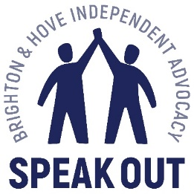
Thank you for taking part in our survey.
Brighton and Hove Speak Out want to know what you think about the work we do. This will help us plan what we do in the future.
Please answer the questions below. You can ask someone at Speak out to support you to do this if you need help.
 | Question | Answer
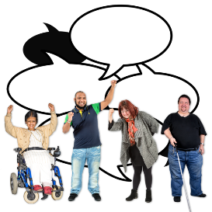 | Can you tell us what you think the word advocacy means?
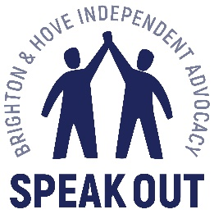 | Please tell us what support you get from Speak Out. This includes one or more of the following  - groups  - drops ins  - have an advocate  Please tell us how this has helped you.
 | What do you think are the main problems that people with learning disabilities face?
 | What effect has coronavirus had on your life?
 | Apart from coronavirus, are there other things that get in the way of you joining in with Speak Out groups and activities?
 | What other things do you think that Speak Out could do to help people with learning disabilities?

