- Good support is important.
It helps people with learning disabilities lead happier, healthier lives.

- Speak Out wants to hear what you have to say!
Tell us what you think of the support you get.

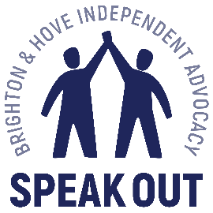
- You can fill in this form
Or contact
emmalopez@bhspeakout.org.uk

Emma
01273 421 921

- We will keep your information confidential.
This means we will not share your details with anyone else.

Where do you live?
Residential home ☐
Independent ☐
With family ☐
Supported living ☐
Shared lives
I do not know ☐
Other ☐
Click or tap here to enter text.

Do you go to day services, activities or groups?
No ☐
Yes ☐
Grace Eyre ☐
Spiral ☐
Carousel ☐
Amaze ☐
Speak Out ☐
I do not know ☐
Other ☐
Click or tap here to enter text.

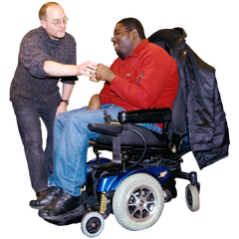
What sort of support do you get?
Family ☐
Shared Lives Carer ☐
Community Support worker ☐
Supported living outreach ☐
Support living house staff ☐
Staff at group home ☐
Social worker ☐
Partner ☐
Respite ☐
None ☐
I do not know ☐
Click or tap here to enter text.

What do you get support with?
Personal care ☐
Cooking ☐
Cleaning ☐
Shopping ☐
Money ☐
Benefits ☐
Going out ☐
Practising my faith ☐
Things like prayer or going to mosque, church or different religious groups

Doing activities ☐
Medical appointments ☐
Keeping healthy ☐
I do not know ☐
Other ☐
Click or tap here to enter text.

Who provides your support?
Grace Eyre ☐
Frances Taylor ☐
Southdown ☐
Community support team ☐
I do not know ☐
Other ☐
Click or tap here to enter text.

Do you know who to contact about your support?
Yes ☐
No ☐
I do not know ☐
Click or tap here to enter text.

If there is a problem can you tell them about it?
Yes ☐
No ☐
I do not know ☐
Click or tap here to enter text.

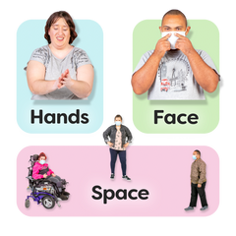
Has your support changed since Covid19?
Yes ☐
No ☐
I do not know ☐
Click or tap here to enter text.

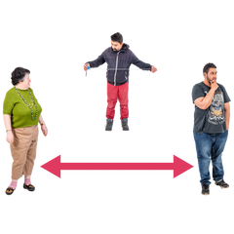
Have your activities or day services changed since Covid19?
Yes ☐
No
I do not know ☐
Click or tap here to enter text.

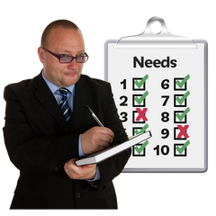
Do you think that people really understand what support you need?
Yes ☐
No ☐
I do not know ☐

Click or tap here to enter text.

What would you change about the support you get?
More time ☐
Less time ☐
More choice ☐
Support with different things ☐
Better communication ☐
Different support worker ☐
I would not change anything ☐
I do not know ☐
Other ☐

Click or tap here to enter text.

Do you have enough money to pay for the support you need?
Yes ☐
No ☐
I do not know ☐
Click or tap here to enter text.

Have you had to stop doing something you like because you don’t have support?
Yes ☐
No ☐
I do not know ☐
Click or tap here to enter text.

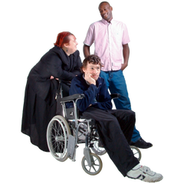
Is there anything you cannot do because you do not have support?
Yes ☐
No ☐
I do not know ☐
Click or tap here to enter text.

Click or tap here to enter text.
Tell us what support works well for you

Tell us what support does not work for you
Click or tap here to enter text.

What worries you about support in the future?
Click or tap here to enter text.

Is there anything else you’d like to tell us?
Click or tap here to enter text.

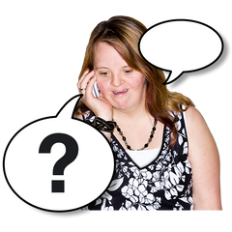
Would you like Speak out to contact you?
Yes ☐
No ☐

Name
Click or tap here to enter text.

Address
Click or tap here to enter text.

Phone
Click or tap here to enter text.

Email
Click or tap here to enter text.

